# Apendix C (RabbitMQ Perf tool installation and configuration)

For the RabbitMQ Perf test tool installation you will require to:

1. Download the tool from the repository (<https://github.com/rabbitmq/rabbitmq-perf-test>)
2. Download Maven (<https://maven.apache.org/download.cgi>)
3. Download Eclipse if not already installed (<https://www.eclipse.org/downloads/>)

Once you have completed the instructions above, is time to start with the installation of the tool.

Step 1 – Go to File and click the Import..

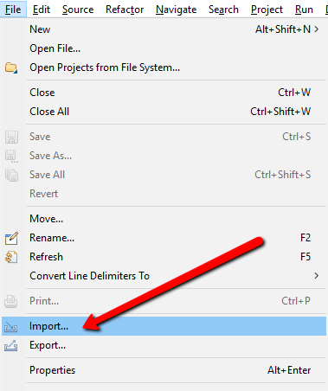

Image 1 - Eclipse Import

Step 2 – Select Maven and Existing Maven Projects and click next

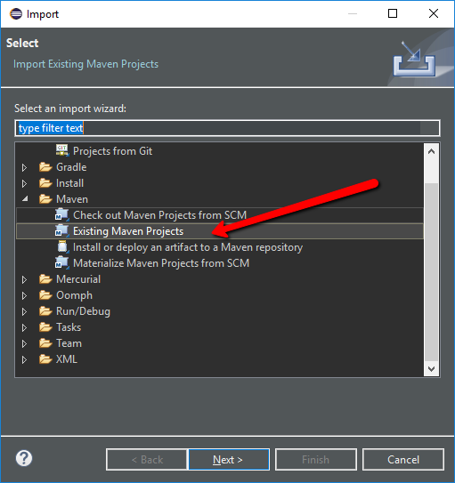

Image 2 - Import Maven Project

Step 3 – Select the directory for the tool repository (Make sure to be pointing where the pom.xml file is) and click finish

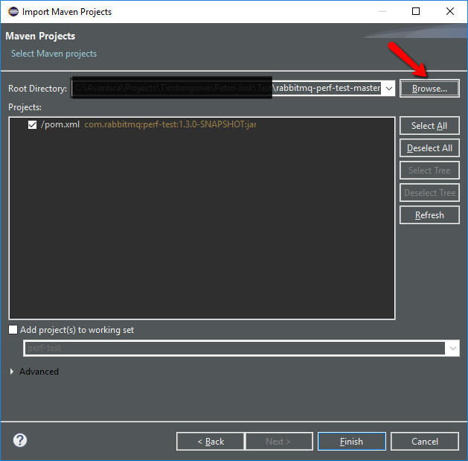

Image 3 - Import the pom.xml file which will load the project

At this point the “perf-test” project should be loaded in your Eclipse (as shown in Image 4)

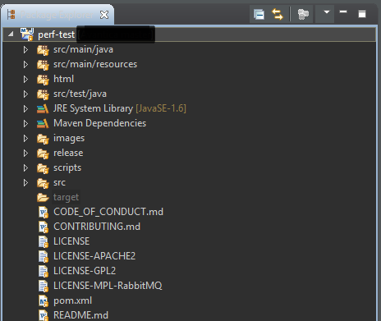

Image 4 - Perf-Test project loaded in eclipse